Session 7

- Create two Python lists: one representing the number of hours you spend on Instagram each day for a week, and another for the number of posts you make each day. Plot these as a scatter plot using matplotlib and visually describe whether the relationship looks like a positive, negative, or zero correlation.

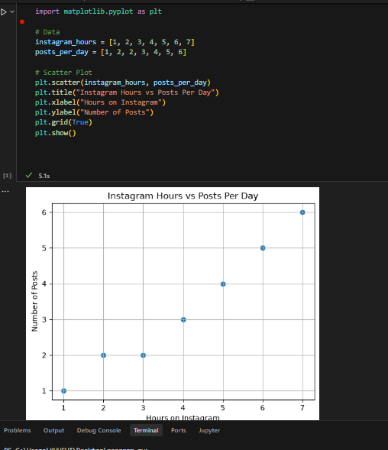

Result
The scatter plot shows a positive correlation because as Instagram usage hours increase, the number of posts also increases.
2. Given the following data for 6 friends: their monthly Zomato order count and their monthly Swiggy order count, calculate the correlation coefficient between the two lists using numpy's corrcoef(). Print the result and explain if the correlation is positive, negative, or zero.
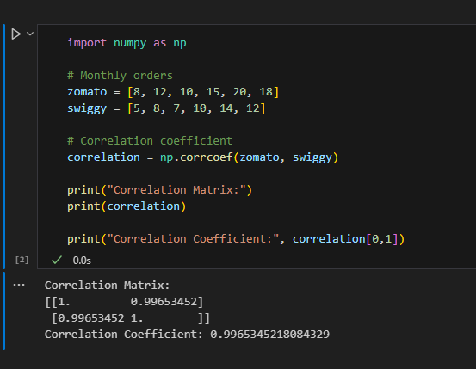

Interpretation
The correlation coefficient is approximately 0.99, which indicates a strong positive correlation. As Zomato orders increase, Swiggy orders also tend to increase.
3.Think of two variables from your daily life (for example, number of YouTube videos watched per day and daily study hours). Write a short paragraph describing whether you expect a positive, negative, or zero correlation between them, and why.
I selected daily study hours and marks scored in tests. These two variables are expected to have a positive correlation because students who spend more time studying usually perform better in exams. Although other factors like concentration and preparation methods also matter, increasing study hours generally helps improve marks.
4. Use ChatGPT to generate a small dataset (10 pairs of numbers) that shows a strong negative correlation between time spent on Spotify and marks scored in a test. Paste the dataset and plot it as a scatter plot using matplotlib.<br><br><em><strong>Hint:</strong> Ask ChatGPT to "generate 10 pairs of numbers with a strong negative correlation" and specify your variables.</em>

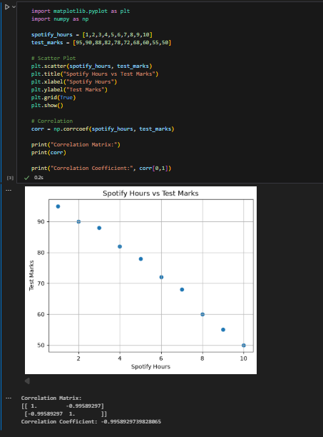
The scatter plot shows a strong negative correlation because as time spent on Spotify increases, test marks decrease.

